AN INTERNSHIP PROJECT REPORT
ON
“IPL Data Analysis Using Python”
Session: 2026–2027
Internship Area: Data Science
Internship Project: Exploratory Data Analysis and Visualization

SUBMITTED BY  Vedant Manoj Kengale  (123B1F044) | PROJECT SUPERVISION  Project Mentor / Supervisor

Table of Contents
Section | Page
1. Project Definition and Objectives | 3
2. Data Collection and Preparation | 4
3. Exploratory Data Analysis (EDA) | 5
4. Analytical Findings and Performance Analysis | 9
5. Validation and Interpretation of Results | 13
6. Presentation and Reporting | 15
7. Conclusion | 16
8. References and Internship Deliverables | 17

This report documents the IPL Data Analysis project completed as part of the Data Science internship. The structure follows a formal project-report format covering project objectives, data preparation, exploratory analysis, analytical findings, result interpretation, documentation, and deliverables.

1. Project Definition and Objectives
1.1 Project Objective
The objective of this internship project is to analyze Indian Premier League (IPL) match-level and ball-by-ball delivery data using Python and derive meaningful insights related to team performance, player performance, match outcomes, venues, dismissals, over-wise scoring patterns, and toss decisions.
The project applies an end-to-end exploratory data analysis workflow. The raw datasets are loaded into Pandas DataFrames, inspected for structure and quality, cleaned where required, transformed using aggregation and grouping operations, and analyzed through statistical summaries and visualizations.
1.2 Project Goals
- Load and inspect IPL match and delivery datasets using Python.
- Understand the structure, dimensions, variables, and distributions of the datasets.
- Identify and correct inconsistent team names and selected missing values.
- Analyze team participation, title wins, batting, bowling, and fielding performance.
- Identify important trends across venues, dismissal types, overs, and toss decisions.
- Create clear and professional visualizations for communicating findings.
- Develop practical Data Science skills through a complete real-world analytics task.
1.3 Project Scope
The scope of the project is exploratory and descriptive. It focuses on understanding historical IPL data and generating insights from observed patterns. The task does not include deployment of a predictive machine learning model. The emphasis is on data preparation, analytical reasoning, visualization, and professional reporting.

2. Data Collection and Preparation
2.1 Data Sources
The project uses two CSV datasets: matches.csv and deliveries.csv. The matches dataset contains match-level information such as season, city, date, teams, toss decision, winner, result, target, venue, and officials. The deliveries dataset contains ball-by-ball information such as batting team, bowling team, over, batter, bowler, runs, extras, wickets, dismissal type, and fielder.
2.2 Data Loading and Inspection
The datasets were loaded into Pandas DataFrames using pd.read_csv(). Initial inspection was performed using head(), shape, and value_counts() operations to understand the available records and categorical distributions.
Data Inspection Summary:
Dataset | Records | Columns
matches.csv | 1,095 | 20
deliveries.csv | 260,920 | 17
The matches dataset includes categorical fields such as season, city, venue, teams, toss decision, winner, and result, while the delivery dataset combines categorical and numerical fields representing individual ball events.
2.3 Data Preparation
- Team-name standardization was performed to avoid duplicate categories caused by naming variations.
- “Rising Pune Supergiants” was standardized to “Rising Pune Supergiant”.
- “Royal Challengers Bengaluru” was standardized to “Royal Challengers Bangalore” in the relevant match-level fields.
- Missing city values were identified and filled with “Unknown”.
- Missing method values were filled with “Non D/L” for consistent analysis.
- Run-out dismissals were excluded from the wicket count when identifying leading bowlers.
A data-quality point observed during execution was the presence of Pandas FutureWarning messages for some inplace operations. These operations can be modernized using direct column assignment in a production implementation.

3. Exploratory Data Analysis (EDA)
3.1 Data Visualization
Exploratory Data Analysis was performed using Matplotlib and Seaborn. The notebook uses bar charts, scatter plots, pie charts, line plots, and count plots to transform aggregated values into interpretable visual information.
The major visualization categories include team success, IPL title wins, top run scorers, individual batting performance, top wicket-takers, bowling performance, match-hosting cities, dismissal types, fielding performance, over-by-over trends, and toss decisions.
3.2 Team Success Analysis
The notebook calculates a success_ratio metric using the number of matches grouped by winner divided by the number of matches grouped by team1. The resulting values are sorted in descending order and presented as a bar chart.
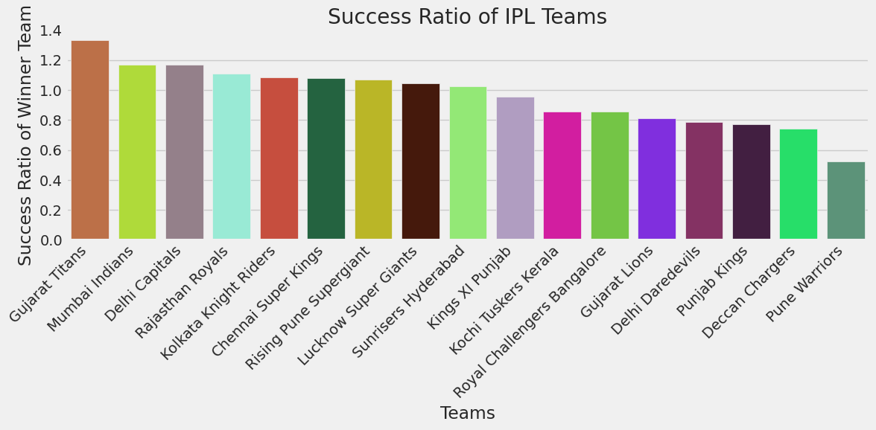
Figure 1: Success ratio of IPL teams generated by the project.
The visualization places Gujarat Titans at the top of the implemented metric, followed by other high-performing teams. The metric is treated as a project-specific analytical measure rather than an official win percentage because its numerator and denominator are based on different grouping definitions.
3.3 IPL Title Wins
Season-winning teams were grouped and counted to identify the number of title wins represented in the analyzed data.
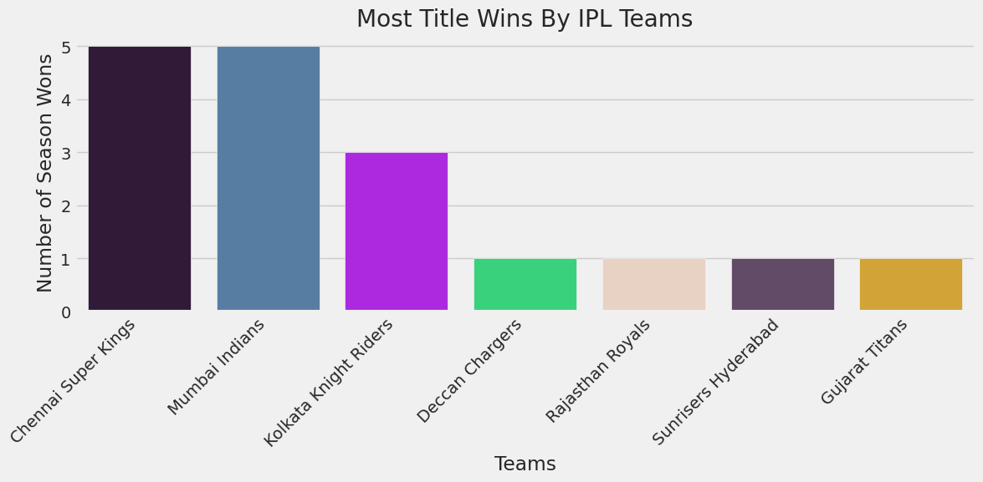
Figure 2: Number of IPL title wins in the analyzed dataset.
The output shows Chennai Super Kings and Mumbai Indians with five title wins each, followed by Kolkata Knight Riders with three title wins.

3. Exploratory Data Analysis (EDA) - Continued
3.4 Top Run Scorers
The top-run analysis groups ball-by-ball records by batter and sums batsman_runs. The top ten players are selected after sorting the aggregated totals in descending order.
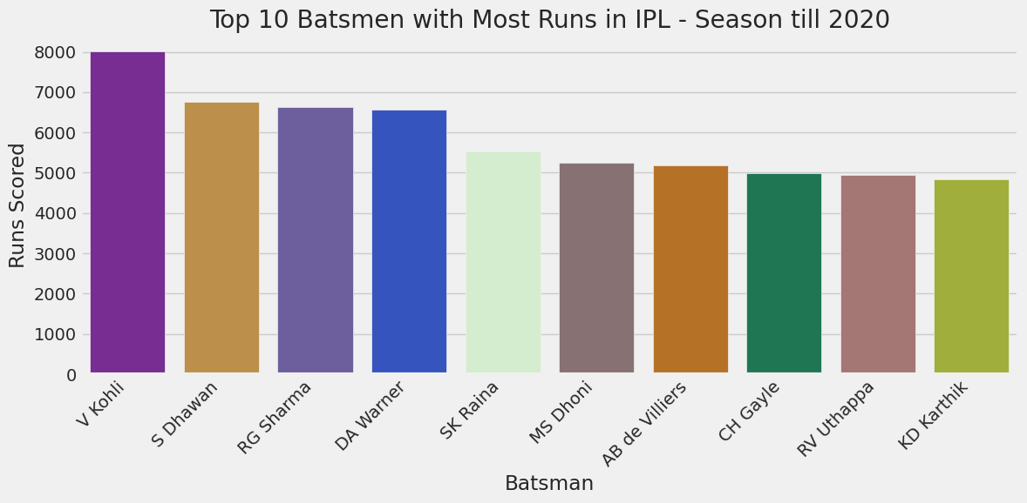
Figure 3: Top ten batsmen by total runs.
V. Kohli appears as the leading run scorer in the submitted visualization, followed by S. Dhawan, R. G. Sharma, D. A. Warner, S. K. Raina, M. S. Dhoni, A. B. de Villiers, C. H. Gayle, R. V. Uthappa, and K. D. Karthik.
3.5 Individual Batting Performance
For selected high-scoring innings, the project calculates innings runs, balls faced, and strike rate. Strike rate is calculated as innings runs multiplied by 100 divided by balls faced.
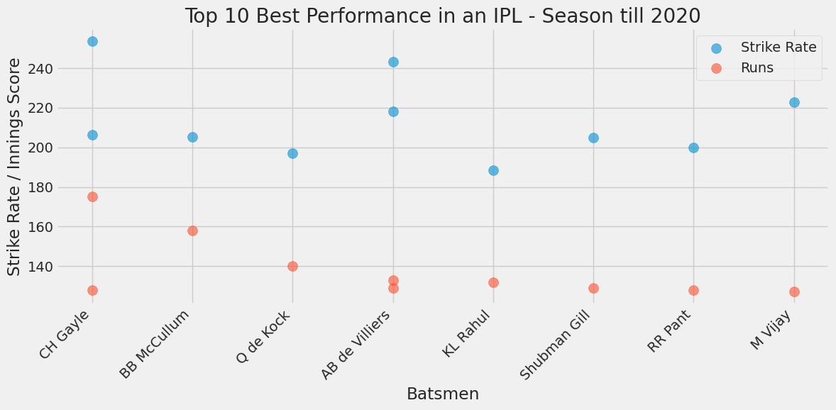
Figure 4: Comparison of innings runs and strike rate for selected batting performances.
3.6 Bowling Analysis
Wicket counts were calculated by excluding run-out dismissals from the bowling wicket analysis. The grouped results were sorted to identify the top ten wicket-takers.
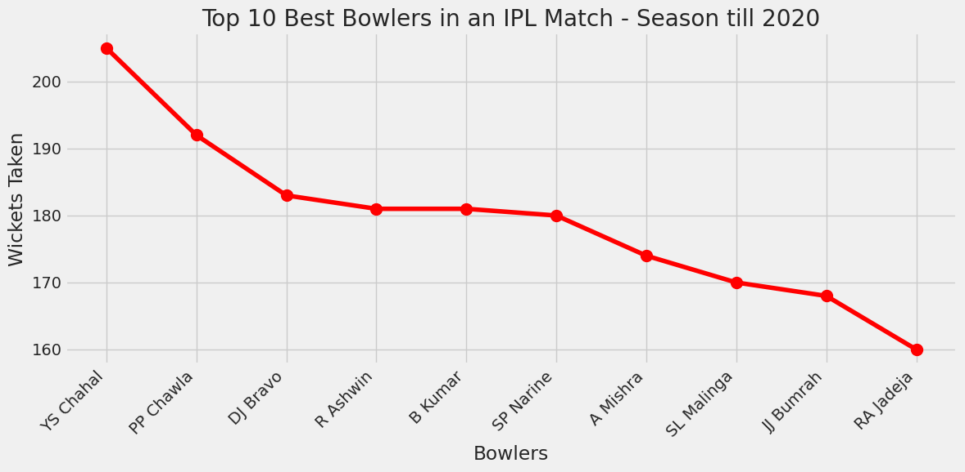
Figure 5: Top ten bowlers by wickets.
Y. S. Chahal ranks first in the submitted top-ten wicket visualization, followed by other leading IPL bowlers.

4. Analytical Findings and Performance Analysis
4.1 Bowling Performance
The notebook extends the bowling analysis by combining wickets and runs conceded for selected match-level performances. A runs-per-wicket metric is derived to compare wicket-taking output with the runs conceded.
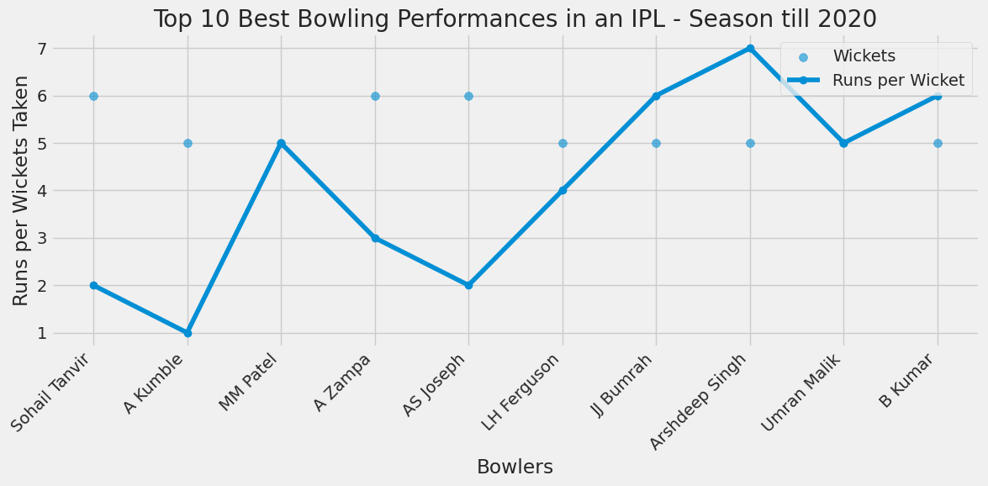
Figure 6: Selected bowling performances using wickets and runs per wicket.
4.2 Match-Hosting Cities
The city analysis counts the number of matches hosted by each city and selects the top locations for visualization.
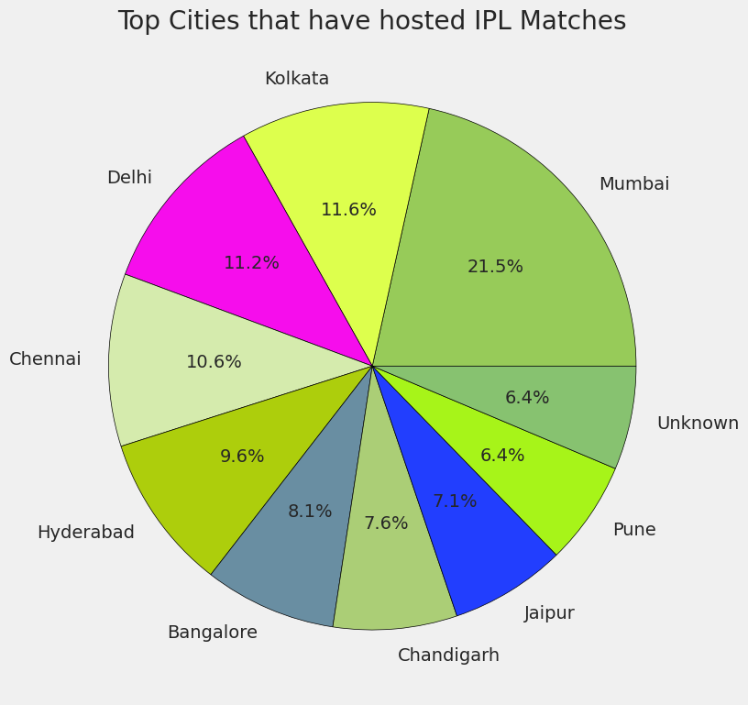
Figure 7: Distribution of matches across leading IPL cities.
Mumbai has the largest representation among the leading cities in the submitted output, followed by Kolkata, Delhi, Chennai, Hyderabad, Bangalore, Chandigarh, Jaipur, Pune, and the Unknown category.
4.3 Dismissal Patterns
The dismissal analysis uses the dismissal_kind field to determine the frequency of different wicket types.
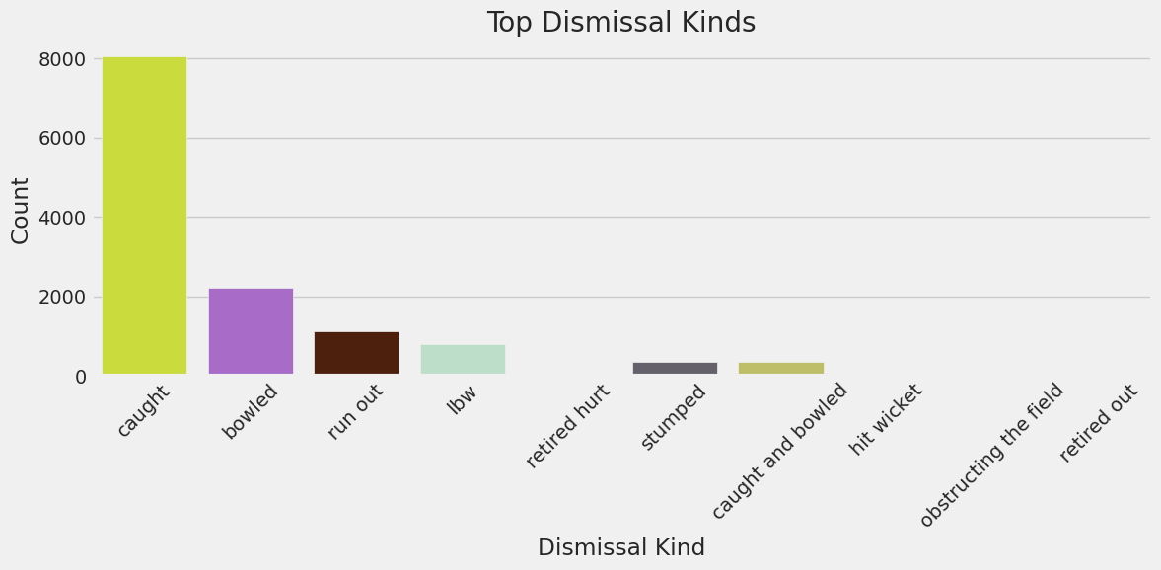
Figure 8: Distribution of dismissal types.
Caught dismissals form the dominant category, followed by bowled, run out, and LBW. The visualization also records less frequent forms such as stumped, hit wicket, retired hurt, and obstructing the field.
4.4 Fielding Performance
The fielding analysis counts the fielder field and extracts the top ten fielders based on recorded dismissal involvement.
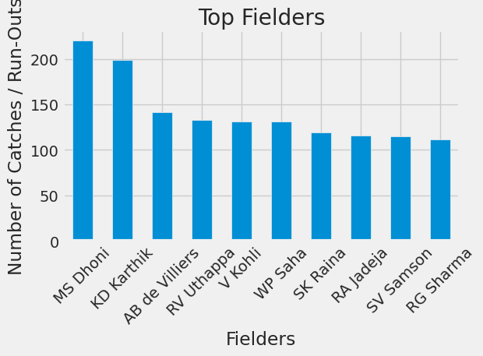
Figure 9: Top fielders based on recorded fielding involvement.
MS Dhoni appears at the top of the submitted fielding visualization, followed by KD Karthik and AB de Villiers.

5. Validation and Interpretation of Results
5.1 Over-by-Over Analysis
The project groups delivery records by over and aggregates total runs, wickets, extra runs, and batsman runs. The resulting visualization makes it possible to compare the scoring and wicket patterns across the innings.
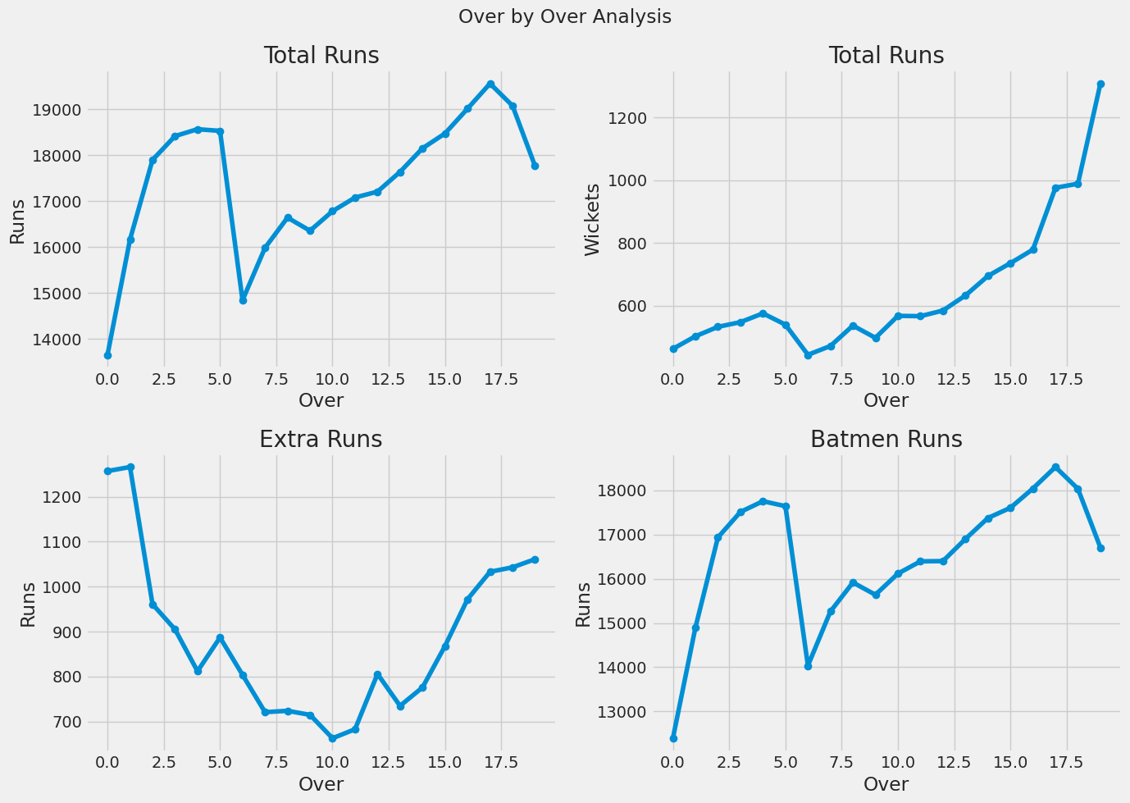
Figure 10: Over-by-over analysis of runs, wickets, extras, and batsman runs.
5.2 Toss Decision Analysis
The toss decision analysis counts the frequency of bat and field decisions made by the toss-winning team.
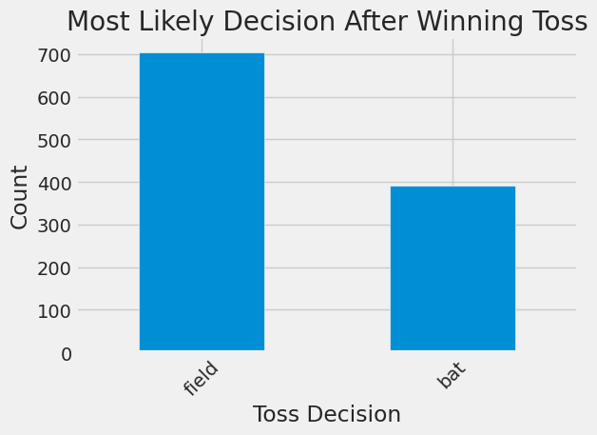
Figure 11: Distribution of toss decisions.
The submitted output shows that choosing to field is more common than choosing to bat after winning the toss.
5.3 Key Insights
- Mumbai Indians, Chennai Super Kings, Kolkata Knight Riders, and Royal Challengers Bangalore are among the highly represented teams across the match records.
- Chennai Super Kings and Mumbai Indians have the highest title count in the submitted title-win visualization, with five each.
- V. Kohli is the leading run scorer in the top-ten batsmen visualization.
- Y. S. Chahal ranks first in the top-ten wicket-takers visualization.
- Mumbai is the leading match-hosting city in the submitted city visualization.
- Caught dismissals are substantially more frequent than other dismissal types.
- MS Dhoni leads the submitted fielding involvement visualization.
- Fielding is the more frequent toss decision in the analyzed data.
- The over-wise analysis provides a compact view of scoring and wicket activity throughout an innings.
5.4 Analytical Quality Checks
The project includes basic validation through repeated value counts, grouped summaries, sorting, and visual inspection of analytical outputs. These checks help confirm that aggregation results are consistent with the underlying categorical and numerical fields. The custom success_ratio should be treated as a project-specific metric, not as a conventional win percentage; a future version should calculate wins divided by matches played for a standard performance KPI.
6. Presentation and Reporting
6.1 Documentation of Process
The project process is organized in a Jupyter/Google Colab notebook. Each analytical stage is represented through Python code cells and visual outputs. The workflow is structured around data loading, inspection, data cleaning, aggregation, performance analysis, and visualization.
6.2 Visual Reports
- Team success visualization for comparative analysis.
- Title-win visualization for season-level achievement.
- Top-run-scorer and batting-performance visualizations.
- Top-wicket-taker and bowling-performance visualizations.
- City distribution and venue-related analysis.
- Dismissal-type and fielding-performance analysis.
- Over-wise scoring and wicket trend visualization.
- Toss-decision distribution visualization.
6.3 Project Summary of Findings
Analysis Area | Primary Observation
Team Titles | CSK and MI have five title wins each in the analyzed title-count output.
Top Run Scorer | V. Kohli leads the top-ten run-scorer visualization.
Top Wicket-Taker | Y. S. Chahal leads the top-ten wicket visualization.
Match City | Mumbai has the largest share among the leading cities.
Dismissal Type | Caught is the dominant dismissal category.
Fielding | MS Dhoni leads the submitted fielding visualization.
Toss Decision | Fielding is more frequently selected than batting.
6.4 Internship Learning Outcomes
- Practical use of Pandas DataFrames and CSV data.
- Experience with data cleaning and categorical standardization.
- Hands-on use of groupby, aggregation, sorting, merging, and value_counts.
- Creation and interpretation of analytical visualizations.
- Understanding of derived metrics such as strike rate and runs per wicket.
- Improved ability to communicate data-driven findings in a structured format.
- Awareness of data-quality issues and metric-definition considerations.

7. Conclusion
The IPL Data Analysis project successfully applies Python-based Data Science techniques to a real sports dataset. By combining match-level and ball-by-ball delivery data, the project transforms raw records into meaningful analytical outputs related to teams, players, bowling, fielding, venues, dismissals, over-wise trends, and toss decisions.
The project demonstrates a complete exploratory analysis lifecycle: data loading, data inspection, data cleaning, aggregation, metric calculation, visualization, and interpretation. It therefore serves as a relevant internship-level implementation of practical Data Science concepts.
The analysis also demonstrates the importance of analytical quality. In particular, the custom success_ratio metric is useful for understanding the notebook logic, but it should not be treated as a conventional win percentage without revising its calculation. Similar care is required when interpreting fielding counts and team-name variations.
7.1 Limitations
- The project is exploratory and does not implement predictive machine learning.
- The custom success metric requires refinement for conventional KPI reporting.
- Historical team-name variations require a more complete franchise mapping strategy.
- Fielder counts combine different fielding events unless the dismissal type is separated.
- The current implementation uses some inplace Pandas operations that should be modernized.
7.2 Future Scope
- Build a standardized franchise mapping table for historical team names.
- Introduce a mathematically correct team win-percentage KPI.
- Create an interactive dashboard using Power BI, Tableau, or Streamlit.
- Extend the project to season-wise trend analysis and venue-level comparisons.
- Add phase-based analysis for Powerplay, middle overs, and death overs.
- Develop predictive models for match outcomes, player performance, or expected score.
- Add advanced metrics such as economy rate, dot-ball percentage, boundary percentage, and expected wickets.

8. References and Internship Deliverables
8.1 References
- Project notebook: Project_IPL_Data_Analysis.ipynb.
- IPL match-level dataset: matches.csv.
- IPL delivery-level dataset: deliveries.csv.
- Python libraries used in the project: NumPy, Pandas, Matplotlib, and Seaborn.
- Development environment: Python 3 / Jupyter Notebook / Google Colab.
8.2 Internship Deliverables
Deliverable | Status | Description
Data Analysis Notebook | Completed | Python notebook containing data loading, cleaning, analysis, and visualizations.
IPL Data Analysis Project | Completed | Exploratory analysis covering team, player, match, and toss patterns.
Visual Analytics | Completed | Charts for key findings and comparative analysis.
Project Documentation | Completed | Formal internship project report documenting methodology and findings.
8.3 Submission Statement
This report is submitted as documentation of the IPL Data Analysis task completed during the Data Science internship. It records the analytical workflow, practical implementation, findings, and learning outcomes of the project in a formal project-report format.
Particular | Details
Submitted By | Vedant Manoj Kengale (123B1F044)
Branch | Information Technology
Internship Area | Data Science
Project Title | IPL Data Analysis Using Python

